**TABLE OF CONTENTS**

1. **User Story Requirements**
2. **Project/Sprint Backlog**
3. **Poker Game Estimate**
4. **Sprint 1**
   1. Sprint 1 Goal
   2. Team Working Agreement
   3. Definition of Done
   4. Tasks for Each User Story
   5. Poker estimation table for Sprint 1
   6. Daily Sprint Report for Sprint 1
   7. Sprint 1 Burndown Chart
   8. Sprint 1 Review
5. **Sprint 2**
   1. Sprint 2 Goal
   2. Team Working Agreement
   3. Definition of Done
   4. Tasks for Each User Story
   5. Poker estimation table for Sprint 2
   6. Daily Sprint Report for Sprint 2
   7. Sprint Two Burndown Chart
   8. Sprint 2 Review

**Team Roles:**

Product Owner: Gideon Agyemang Yeboah Akosah

Scrum Master: Sebastiano Pio Matera

Developer: Gideon Agyemang Yeboah Akosah

Developer: Mohammed Arham

Developer: Sebastiano Pio Matera

**1.0 User Story Requirements**

The project requirements translated to User Story format are found below in Table 1

| User Story ID | Requirement | User Story |
| --- | --- | --- |
| 1 | Automated display of products  based on category selected | As a user I want to be able to see  all the products under a certain  category |
| 2 | Ability to navigate to other  pages from the homepage | As a user I want to be able to navigate to all other pages from the  homepage |
| 3 | Quick search for specific products | As a user I want to be able to  quickly search for any product I  want |
| 4 | Fast retrieval of orders from data-  base | As a user I want to quickly retrieve  all my order history |
| 5 | Product reviews for safer shoppin-  experience | As a user I want to see all reviews  products to enable smoother  shopping experience |
| 6 | Detailed product information | As a user I need to be able to view  details about each product to  make informed decision |
| 7 | Easily update the database | As an admin I want to easily add or  remove new products and categories  to database |
| 8 | Statistics for products, customers  and orders | As an admin I want to easily see statistics for the products, customers and orders so I can analyse trends |
| 9 | Select which product to display  and which order to do so | As an admin I want to be able to choose which products to show customers automatically |
| 10 | Contact customers directly via  emails | As an admin I want to be able to send direct emails to all the customers. |
| 11 | Accept credit card payments | As a user I want to be able to make payments with my credit card |
| 12 | Scalable database | As an admin I want the database to be scalable and be able to support any number of products and customers |
| 13 | Products to category structure (creating a parent child relationship between the two) | As an admin I want a one-to-many category-products relationship so that I can easily add new products under a category |
| 14 | View orders so far | As an admin I want to be able to view all the orders and their delivery status |
| 15 | Display of item in cart | As an user I want to see the items I added to the shopping cart in one place before I confirm my order |
| 16 | Display total price of the order | As an user I want to see the total price of the order including any and all fees before I confirm the order |
| 17 | Select what items to remove from cart | As an user I want to have the ability to remove the items from the cart as necessary |
| 18 | Change items quantity in the cart | As an user I want to have the ability to change quantities of the item as required |
| 19 | Displaying estimated delivery date | As an user I want to see the estimated delivery time of the order before I confirm the order |
| 20 | Select what items to remove from cart | As an user I would like the ability to select items to remove from cart |
| 21 | Adding delivery addresses | As an user I would like the ability to select the address of the delivery before I confirm my order |
| 22 | Payment system using SSL | As an user I would like my order transaction to be secured using SSL encryption |
| 23 | Confirmation of payment should be quick | As an user I would like my order and payment to be confirmed within 5 seconds |
| 24 | Displaying ratings of the items in the cart | As an user I would like to see the product ratings of the item in the cart |
| 25 | Refreshing of the cart should be instantaneous | As an user I would like the checkout to not refresh when I make changes to the cart |

**Table 1. User Story**

**2.0 Project/Sprint Backlog**

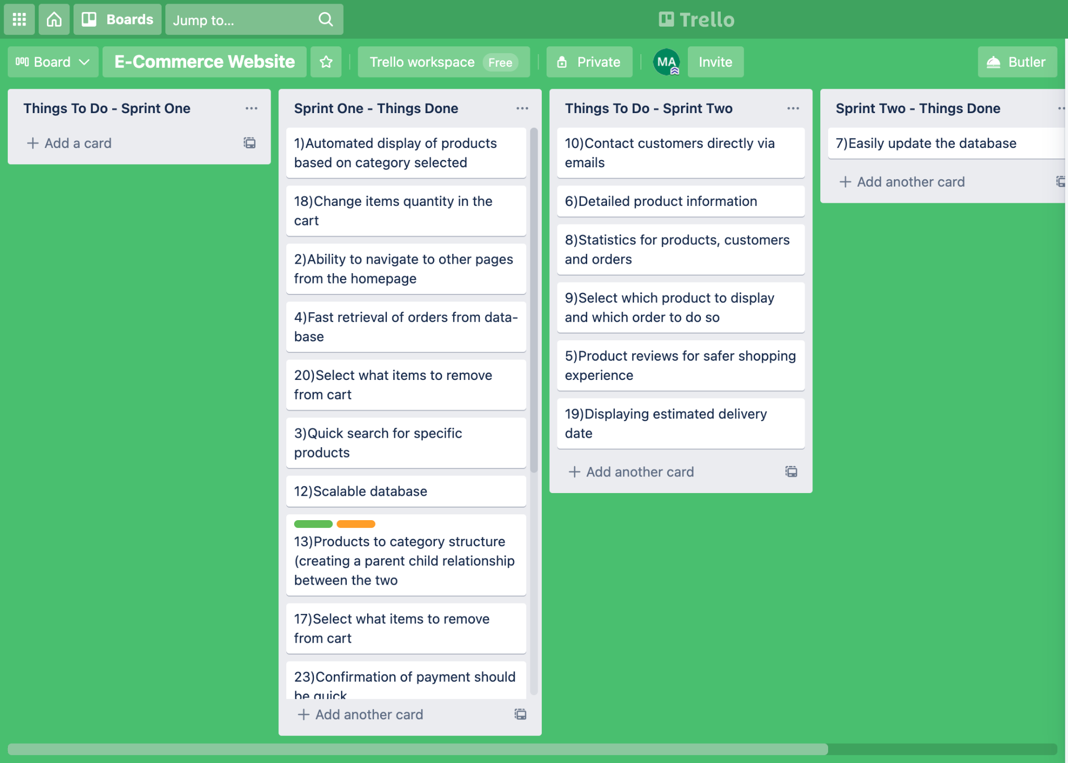

**Figure 1 - Product backlog and sprint planning overview**

For our sprint planning we made use of the online tool called “Trello”. This platform allows us to make a planning board and create tasks on the planning board. We created four subsections, each pertaining to the two sprints we want to carry out. We then create a task under the “Things to do” section, everytime we finish a task, we move it from “Things to do” to “Things done”. If there are any tasks that we didn’t manage to complete on sprint one, we would simply move the task to the to do section of the next sprint. This way we ensure all the user stories are completed in the two planned sprints and it allows the developers to to estimate how much of the product remains to be completed.

**3.0 Poker Game Estimate**

The Poker Game Estimation Method, along with the Fibonacci Estimate Values allows us to estimate how long would a user story take to complete. This includes the programming complexity of the user story, the programming ability of the developers and any other difficulties that may hinder the time taken to complete the user stories.

**How it is played:**

All the developers meet together to discuss the user stories and give it a size/difficulty level rating of 1,2,3,5,8 and 13. 1 being the easiest, as such with the lowest estimated time to complete and 13 being the stories that are expected to take the longest time to complete. The reason we use the fibonacci values is the increase of one number to another is not a constant but is of around 60%. This means the numbers vary widely enough from each other that we are able to make a clear distinction between a user story that would be of 8 rating and a one that is of 13 rating. If we used a linear scale, we would have a harder time knowing whether to give a story a rating of 8 or 9. The developers will keep having rounds of discussion until a general consensus of the rating is reached, that all the developers can agree with.

**Assumption for all sprints:**

1. For each sprint we would carry out Poker Game estimation for the user stories planned for that particular sprint.
2. We plan for each developer to finish one user story per day, giving him one story point per day.
3. We also assume that each developer would work for the same number of hours every day for simplicity purposes.
4. We assign the percentage of planned tasks finished each day for each developer by using a random number generator, which randomly assigns a value from 0% to 150%. When a developer gets a value above 100% it means the developer achieved more tasks than what was planned for him that particular day.
5. If a user story is not finished within the allotted sprint, we would move the user story to the next sprint.

**4.0 Sprint 1**

***4.1 Sprint 1 Goal***

For Sprint 1, we would like to build the basic foundational framework, whether it be the frontend or backend, of the shopping system. The administrator needs to be able to have an overview of the sales happening. The user should be able to search for products, add products to shopping carts, and finally purchase products.

***4.2 Team Working Agreement***

The team working agreement for the first sprint is shown below in table 2:

| **Ceremonies** | |
| --- | --- |
| **Stand Up:** | Daily start at 1 pm |
| **Working Hours:** | No more than 6 hours daily from Thursday to Monday |
| **Iteration Scrum Meeting:** | 15mins at 11am every 3 days |
| **Roadmap Planning:** | Once a week |
| **Duration:** | March 19 - April 7 |
| ***Communication/Tools*** | |
| **Project Discussion:** | WhatsApp  Facebook Messenger |
| **Document Sharing/Artifact Saving:** | Google Drive and Doc  Github  WhatsApp |
| ***Object*** | |
| **Sprint Object:** | Construction of the backend and frontend by the developers in sprint 1. Setting up the database system in the backend. Setting up the administrator system. Setting up the product searching and buying system. |
| **Test Object:** | No bug in searching for products  No bug in shopping cart |
| **Demo and Review:** | Demo to product owner |
| ***Comments:*** | |
| In the Sprint 1, the online shopping system basic framework needs to be built and is under Gideon, Arham and Seba responsibility. The product owner is Gideon and the scrum master is Seba. Sprint 1 should be finished no later than April 7th. If the developing group finishes and satisfies the PO's requirement, the PO will give the developing group 10% bonus. If the developing group can not finish the object on April 7th or can not satisfy the PO's requirement, the scrum master should reschedule the plan and report to the product owner. | |

**Table 2. Team Working Agreement**

***4.3 Definition of Done***

1. Finish setting up the basic frontend and backend of the shopping system.
2. Finish setting up the product database and the customer database
3. Finish setting up the product payment system
4. Finish the testing of searching for products using various categories, adding the products to the shopping cart and finally purchasing the products.
5. Finish setting up the framework for the administrator system.
6. Finish demo the product and its functions to ensure smooth user experience.

***4.4 Task for Each User Story***

| **ID** | **Title** | **Release** | **Task** | |
| --- | --- | --- | --- | --- |
| 2 | Ability to navigate to other  pages from the homepage | Sprint 1 | **Task 1:** set up the various pages needed to allow easy and sensible browsing of the system |  |
| 3 | Quick search for specific products | Sprint 1 | **Task 1:** connect the product database to the webpage | **Task 2:** unit test to ensure the right filtering of the products takes place |
| 7 | Easily update the database | Sprint 1 | **Task 1:** set up the product database as to ensure that we can easily add more products manually or by using a online catalogue |  |
| 8 | Statistics for products, customers  and orders | Sprint 1 | **Task 1:** set up the basic statistics for the order made to be able to viewed in the admin page |  |
| 15 | Display of item in cart | Sprint 1 | **Task 1:** set up the add to cart function | **Task 2:** unit test to ensure the items appear in the cart |
| 16 | Display total price of the order | Sprint 1 | **Task 1:** set up a function that calculates the total price of the products in the cart and shows it | **Task 2:** unit test to check if the price updates when removing or editing a product |
| 17 | Select what items to remove from cart | Sprint 1 | **Task 1:** set up the function to delete item from the cart | **Task 2:** unit test this task |
| 18 | Change items quantity in the cart | Sprint 1 | **Task 1:** set up the function to change the quantity of item from the cart | **Task 2:** unit test this task |
| 19 | Displaying estimated delivery date | Sprint 1 | **Task 1:** set up the function to view the estimated delivery time from the address provided using api | **Task 2:** unit test this task |
| 21 | Adding delivery addresses | Sprint 1 | **Task 1:** set up the function to add delivery address before finalizing order | **Task 2:** unit test this task |
| 22 | Payment system using SSL | Sprint 1 | **Task 1:** set up the payment system to use SSL when using credit cards | **Task 2:** unit test this task |
| 23 | Confirmation of payment should be quick | Sprint 1 | **Task 1:** set up the function to show the user the output of confirmation after an order has been placed | **Task 2:** unit test this task |
| 24 | Displaying ratings of the items in the cart | Sprint 1 | **Task 1:** show the rating of the items while the item is in the cart | **Task 2:** unit test this task |
| 25 | Refreshing of the cart should be instantaneous | Sprint 1 | **Task 1:** set up the cart with time efficiency in mind | **Task 2:** unit test this task to ensure the time is below 1 second |

**Table 3. Tasks breakdown for Sprint 1**

***4.5 Poker estimation table for Sprint 1***

| ***Story ID*** | ***Consensus*** | ***Rounds Played*** | ***Discussion*** |
| --- | --- | --- | --- |
| 2 | 8 | 1 | Since all the developers have used shopping websites extensively and have made simple web pages before, they have a good idea of how the framework of such a system needs to be set up. However it's a tedious process so the process would take a long time. |
| 3 | 5 | 1 | Since we would have to build the product database from scratch we thought it would be of a bit of difficulty, but simply because we are setting it up from scratch. |
| 7 | 5 | 1 | This requires choosing a good framework for database usage, which we were kind of apprehensive about but realized that there should be enough resources available for such a common function as this |
| 8 | 5 | 1 | This we all agreed would also have enough resources on the net, we may also find a template or so. However, finding statistics from the database and presenting on the admin system seemed difficult as none of us did that before |
| 15 | 8 | 1 | The problem with this one would be setting up and connecting the product database properly, to ensure the items are added correctly to the cart. So this too should have enough documentations online to help us through so it should not take that long. |
| 16 | 2 | 1 | Once we get the cart ready, such functions should be trivial. |
| 17 | 2 | 1 | Once we get the cart ready, such functions should be trivial. |
| 18 | 2 | 1 | Once we get the cart ready, such functions should be trivial. |
| 19 | 3 | 1 | Arham wasn’t sure how to calculate the delivery time exactly since a user could order from any parts of the UAE. Gideon suggested that maybe we could use a third party API to carry out such a task. Seba said that since he has experience using such API he should be able to find his way around this. |
| 21 | 5 | 1 | This shouldn’t take long as we are just storing addresses just like how we store products. So if we get the previous systems to work this too shall be easy. |
| 22 | 8 | 1 | This will take a bit of work as we would be using API for such transactions and Seba and Gideon are the only developers who have worked with API, even then this would be new to them. |
| 23 | 8 | 1 | This may take some time since we have a time constraint to follow, so we would need to write code in such a way to minimize the time taken for the order to be placed and confirmed |
| 24 | 5 | 1 | This would be possible but maybe unusual as it's not like we have enough user to test out the rating systems properly, however its a common feature so it should have enough documentation |
| 25 | 8 | 1 | Should be a bit difficult due to the time constraint set, so this means while coding we have to ensure the time complexity is given a priority. |

***Table 4. Poker estimation results and details of sprint 1***

***4.6 Daily Sprint Report for Sprint 1***

This sprint will consist of a total of 79 story points based on the total consensus (see Table 4). We report the points daily, as shown in Table 5.

Randomly generated vacation days (0-2):

1. Arham 0
2. Seba 0
3. Akosah 0

| Date | Arham | Akosah | Seba | % of planned task | Comment |
| --- | --- | --- | --- | --- | --- |
|  | User story assigned | | |  |  |
| 19-Mar | 3 | 2 | 7 | Arham: 20  Gideon: 30  Seba: 30  Total Story Points Burnt Today: 4.6 | Sprint planning and task breakdown took place. |
| 20-Mar | 3 | 2 | 7 | Arham: 20  Gideon:20  Seba:20  Total Story Points Burnt Today:3.6 |  |
| 21-Mar | 3 | 2 | 7 | Arham: 30  Gideon:30  Seba:20  Total Story Points Burnt Today:4.9 |  |
| 22-Mar | 3 | 2 | 7 | Arham: 15  Gideon:10  Seba:15  Total Story Points Burnt Today:2.45 | Scrum meeting took place. |
| 23-Mar | Not a workday | | | | |
| 24-Mar |
| 25-Mar | 3 | 2 | 7 | Arham: 15  Gideon:10  Seba:15  Total Story Points Burnt Today:2.45 | All developers done with their first assigned story. |
| 26-Mar | 8 | 15 | 16 | Arham: 40  Gideon:70  Seba:50  Total Story Points Burnt Today:8.6 |  |
| 27-Mar | 8 | 15 | 16 | Arham: 60  Gideon:30  Seba:50  Total Story Points Burnt Today:6.4 | Scrum meeting took place. |
| 28-Mar | 17 | 18 | 19 | Arham: 70  Gideon:55  Seba:75  Total Story Points Burnt Today:4.75 |  |
| 29-Mar | 17 | 18 | 19 | Arham: 15  Gideon:30  Seba:10  Total Story Points Burnt Today:1.2 |  |
| 30-Mar | Not a workday | | | | |
| 31-Mar |
| 01-Apr | 17 | 18 | 19 | Arham: 15  Gideon:15  Seba:15  Total Story Points Burnt Today:1.05 | Scrum meeting took place. |
| 02-Apr | 21 | 22 | 23 | Arham: 30  Gideon:50  Seba:40  Total Story Points Burnt Today:8.7 |  |
| 03-Apr | 21 | 22 | 23 | Arham: 30  Gideon:50  Seba:60  Total Story Points Burnt Today:10.3 |  |
| 04-Apr | 21 | 24 | 25 | Arham: 40  Gideon:40  Seba:30  Total Story Points Burnt Today:6.4 | Scrum meeting took place. Arham is done with story 21. Arham is done with sprint 1. |
| 05-Apr |  | 24 | 25 | Arham: NA  Gideon:60  Seba:70  Total Story Points Burnt Today:8.6 | Seba is done with user story 25 and sprint 1. Gideon is done with user story 24 and sprint one. |
| 06-Apr | Not a workday | | | | |
| 07-Apr |

**Table 5. Daily Sprint Report**

***4.7 Sprint One Burndown Chart***

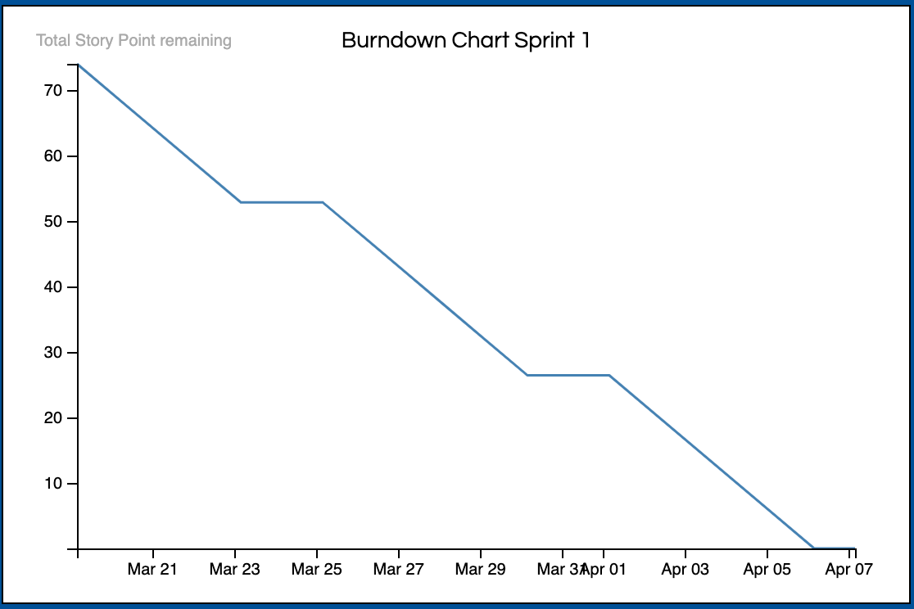

***Figure 2 - Sprint 1 Burndown Chart***

***4.8 Sprint 1 Review***

Total Story Point finished = 74

Team Velocity = 74 points/14 days = 5.28 story points/day

**5.0 Sprint 2**

***5.1 Sprint 2 Goal***

For Sprint 2, we would like to add new modes of statistical analysis to the admin page to help the administrator to visually understand the trend of the sales of products. The customer experience should be as pleasant as possible, when using the system as such the color consistency and accessibility should be maintained.

***5.2 Team Working Agreement***

The team working agreement for the first sprint is shown below in table 2:

| **Ceremonies** | |
| --- | --- |
| **Stand Up:** | Daily start at 1 pm |
| **Working Hours:** | No more than 6 hours daily from Thursday to Monday |
| **Iteration Scrum Meeting:** | 15mins at 11am every 3 days |
| **Roadmap Planning:** | Once a week |
| **Duration:** | April 8 - April 27 |
| ***Communication/Tools*** | |
| **Project Discussion:** | WhatsApp  Facebook Messenger |
| **Document Sharing/Artifact Saving:** | Google Drive and Doc  Github  WhatsApp |
| ***Object*** | |
| **Sprint Object:** | Adding additional statistics to the admin page. Removing white space from UI. Maintaining color consistency across the elements of the webpages. |
| **Test Object:** | No bug in the graphs present in the admin page.  No bugs in the updating of the graphs. |
| **Demo and Review:** | Demo to product owner |
| ***Comments:*** | |
| In the Sprint 2, the user interface of the admin system and customer system should be improved along with the functionalities of the admin and is under Gideon, Arham and Seba responsibility. The product owner is Gideon and the scrum master is Seba. Sprint 2 should be finished no later than April 22nd. If the developing group finishes and satisfies the PO's requirement, the PO will give the developing group 10% bonus. If the developing group can not finish the object on April 22nd or can not satisfy the PO's requirement, the scrum master should reschedule the plan and report to the product owner. | |

**Table 6. Team Working Agreement For Sprint 2**

***5.3 Definition of Done***

1. Adding more functionalities to the admin page.
2. Ensuring the color/brand consistency among all the elements of the web application
3. Ensuring the user interface is pleasant and simple to use

***5.4 Task for Each User Story***

| **ID** | **Title** | **Release** | **Task** | |
| --- | --- | --- | --- | --- |
| 1 | Automated display of products  based on category selected | Sprint 2 | **Task 1:** setting up the database with the fields that allow the categorisation of the products | **Task 2:** Edit data points that already exist to accommodate this change in structure. |
| 4 | Fast retrieval of orders from data-  base | Sprint 2 | **Task 1:** Edit the SQL in order to optimize the retrieval of data | **Task 2:** Allocate more memory to the functionality of data retrieval. |
| 5 | Product reviews for safer shoppin-  experience | Sprint 2 | **Task 1:** Add this data point as a column to the schema. | **Task 2:** Build the HTML/CSS Necessary to receive review data and to display it as well. |
| 6 | Detailed product information | Sprint 2 | **Task 1:** Add this data point as a column to the schema. | **Task 2:** Build the HTML/CSS Necessary to receive review data and to display it as well. |
| 9 | Select which product to display  and which order to do so | Sprint 2 | **Task 1:** Add a column in the schema that takes into consideration the amount of times a product has been purchased. | **Task 2:** Implement HTML/CSS that orders the display of products based on quantity purchased with a combination of reviews. |
| 10 | Contact customers directly via  emails | Sprint 2 | **Task 1:** Write up sample templates for marketing emails and updates on products | **Task 2:** Implement SendPulse API that incorporates automatic marketing campaigns. |
| 12 | Scalable database | Sprint 2 | **Task 1:** Scale up the database server, to have more space and allocate more energy and memory to request and pull data. | **Task 2 (Possibility) :** Shard database and separate them into different serves, and write code to access them all form one cluster. |
| 13 | Products to category structure (creating a parent child relationship between the two) | Sprint 2 | **Task 1:** Recreate the schema of the database on a schema creator tool | **Task 2:** Adjust data points to fit the new structure and add it to the new database with the new schema. |
| 14 | View orders so far | Sprint 2 | **Task 1:** Create a separate database for orders, that have a userID attached to them | **Task 2:** Create a tab (using HTML/CSS) that allows a specific user to look at all of their previous orders |

**Table 7. Tasks breakdown for Sprint 2**

***5.5 Poker estimation table for Sprint 2***

| ***Story ID*** | ***Consensus*** | ***Rounds Played*** | ***Discussion*** |
| --- | --- | --- | --- |
| 1 | 5 | 1 | Since the developers worked on building the basic admin page, adding new functionalities such as these one should not take long. |
| 4 | 8 | 1 | Since we are bound by the time constraint, this does mean we have to be careful with how we approach it, and thus have to ensure we keep the time complexity in mind. This raises the difficulty of the task. |
| 5 | 5 | 1 | This requires setting a database that contains the reviews and the product associated with the reviews. Such setting up of databases will take time to set up as building databases is something Arham is not used to doing. |
| 6 | 5 | 1 | We would also have to have a field in the product database that contains the product description. This in itself should not be hard, but the developers are not sure if changing the database will cause conflicts/bugs in other features, as everything is interconnected. |
| 9 | 8 | 1 | Since we have to allow the admin the option to change which product the admin wants the viewer to see, it requires that when we make changes to the database, the changes should be reflected on the customer end in realtime. Here we have to be careful to ensure the changes don't disrupt the user experience. |
| 10 | 5 | 1 | This should be possible using an email service API. Since we will be using API it will pose some challenge. |
| 12 | 5 | 1 | This requires using a database that is known to be easily scalable. We are aware of databases like that, particularly Gideon who have worked with such databases. |
| 13 | 2 | 1 | This requires setting up the database appropriately, which we did consider in Sprint 1, so doing this now, should not be difficult. |
| 14 | 5 | 1 | This again requires working with the admin page and connecting that page to the multiple databases that we have created. Should not be that difficult. |

***Table 8. Poker estimation results and details of sprint 2***

***5.6 Daily Sprint Report for Sprint 2***

This sprint will consist of a total of 48 story points based on the total consensus (see Table 8). We report the points daily, as shown in Table 9. This report was made on April 14th 2021, as such the sprint report after 14 April has been left blank.

Randomly generated vacation days (0-2):

1. Arham 0
2. Seba 0
3. Akosah 0

| Date | Arham | Akosah | Seba | % of planned task | Comment |
| --- | --- | --- | --- | --- | --- |
|  | User story assigned | | |  |  |
| 8-April | 1 | 4 | 5 | Arham: 20  Gideon: 25  Seba: 30  Total Story Points Burnt Today: 4.5 | Sprint planning and task breakdown took place. |
| 9-April | 1 | 4 | 5 | Arham: 20  Gideon: 25  Seba: 10  Total Story Points Burnt Today: 3.5 |  |
| 10-April | 1 | 4 | 5 | Arham: 30  Gideon:20  Seba:30  Total Story Points Burnt Today: 4.6 | Scrum meeting took place |
| 11-April | 1 | 4 | 5 | Arham: 30  Gideon: 30  Seba: 30  Total Story Points Burnt Today:5.4 |  |
| 12-April | Not a workday | | | | |
| 13-April |
| 14-April | 6 | 9 | 10 | Arham: 20  Gideon:20  Seba:15  Total Story Points Burnt Today:3.35 |  |
| 15-April | 8 | 15 | 16 | Arham:NA  Gideon:NA  Seba:NA  Total Story Points Burnt Today:NA | Scrum meeting should take place today |
| 16-April | 8 | 15 | 16 | Arham:NA  Gideon:NA  Seba:NA  Total Story Points Burnt Today:NA |  |
| 17-April | 17 | 18 | 19 | Arham:NA  Gideon:NA  Seba:NA  Total Story Points Burnt Today:NA |  |
| 18-April | 17 | 18 | 19 | Arham:NA  Gideon:NA  Seba:NA  Total Story Points Burnt Today:NA | Scrum meeting should take place today |
| 19-April | Not a workday | | | | |
| 20-April |
| 21-April | 17 | 18 | 19 | Arham:NA  Gideon:NA  Seba:NA  Total Story Points Burnt Today:NA |  |
| 22-April | 21 | 22 | 23 | Arham:NA  Gideon:NA  Seba:NA  Total Story Points Burnt Today:NA |  |
| 23-April | 21 | 22 | 23 | Arham:NA  Gideon:NA  Seba:NA  Total Story Points Burnt Today:NA | Scrum meeting should take place today |
| 24-April | 21 | 24 | 25 | Arham:NA  Gideon:NA  Seba:NA  Total Story Points Burnt Today:NA |  |
| 25-April |  | 24 | 25 | Arham:NA  Gideon:NA  Seba:NA  Total Story Points Burnt Today:NA |  |
| 26-April | Not a workday | | | | |
| 27-April |

**Table 9. Daily Sprint Report for Sprint 2**

***5.7 Sprint Two Burndown Chart***

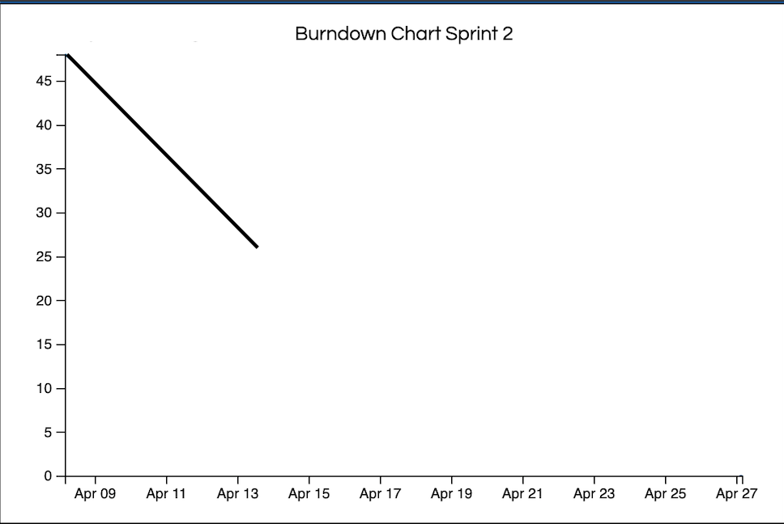

***Figure 3 - Sprint 2 Burndown Chart***

***5.8 Sprint 2 Review***

Total Story Point finished = 21.35

Team Velocity = 21.35 points/5 days = 4.27 story points/day